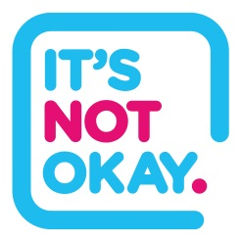
It’s Not Okay In Sport

Dear (INSERT PARENTS/ GUARDIANS/ CARERS NAME),
(INSERT NAME OF CLUB) supports the ‘It’s Not Okay’ campaign in collaboration with public and third sector partners across Greater Manchester.
The aim of the campaign is to raise awareness of child sexual exploitation (CSE), help people to recognise the signs of CSE, encourage people to report it and provide support to victims and those most at risk.
This year the focus is on sport across Greater Manchester. Coaches, players and other sport clubs are teaming up with police, charities and local authorities to send out a clear message to communities that CSE is not welcome in their sports clubs.
We all have a responsibility to understand how to identify the signs of CSE and what to do if we recognise it’s happening to your child. We also need to ensure young people know how to report CSE and where to find the support they need. Children and young people may choose to confide in their coach or team mate, so a knowledge of the subject is vital.
We know that Greater Manchester is a fantastic place for sport and we want to celebrate it while ensuring it is a safe space for children and young people.
We have signed and are displaying an ‘It’s Not Okay’ charter, which reinforces our commitment to tackling and preventing child sexual exploitation from happening within our club.
For more information about CSE, please visit: itsnotokay.co.uk.

